**C. Measures of default mode “resting” brain activity using MEG**

***Resting state brain activity measured with MEG***

Default mode “resting” brain activity refers to the ongoing intrinsic or spontaneous neural activity in the absence of overt task demands. In our study, teens “rest” (translation = daydream) for five minutes while sitting in the MEG machine. Teens’ resting state brain activity reveals the large-scale functional organization of the brain, called “default mode network (DMN).” The DMN shows sustained spontaneous neural activity that is reduced as soon as the person begins to focus on a specific task. The fine temporal resolution of MEG offers an excellent way to characterize the default network of teens’ brains. Once identified, the modulation of the default network in individuals can then be related to that individual’s brain and behavioral measures.

***Connectivity metrics***

By convention, a network is defined by a set of relational objects, or nodes, and edges that represent relationships among nodes. Figure 1, left, shows the location of one such node in the DMN mapped onto the 3D surface of the brain. In the context of functional brain connectivity, a node represents a cortical region of interest (ROI) and edges can represent any number of features used to describe the structural organization of the network. Our first step was to define the nodes that change with age during adolescence. Our analyses to date have revealed a node in the dorsal frontal region that undergoes tremendous change during adolescence (Figure 1, right). This is particularly exciting because the dorsal prefrontal cortex is involved in self-regulatory behavior and social cognition.

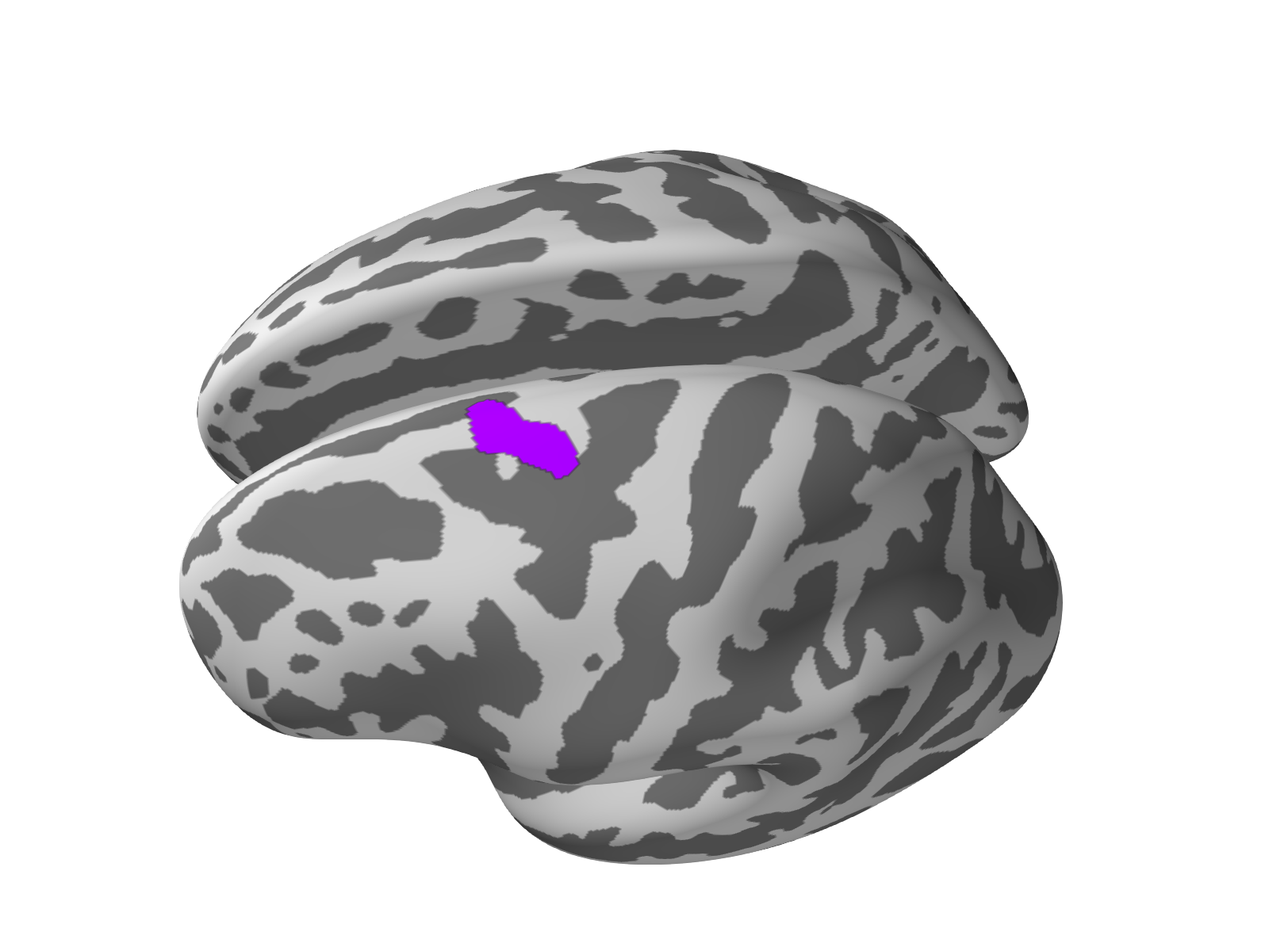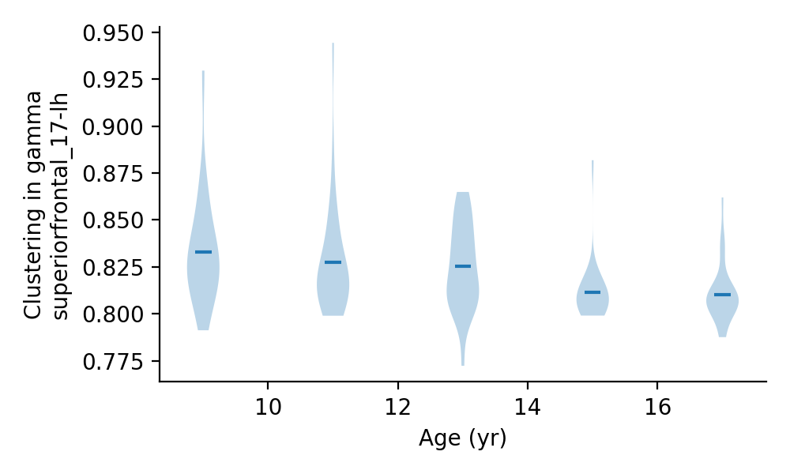

*Figure 1. In the abstract networks are visualized by representing each node as a circle and lines or edges between nodes that share a relationship or connection. The left panel shows the location of a brain region that as a single node within the adolescent brains’ DMN shows remarkable change in local clustering connectivity over time with age. The right panel shows the pattern of reduction in average (hash marks) local clustering connectivity for this node over time. The local clustering connectivity measures the density of edges amongst neighboring nodes, thus for this ROI, edges or connections amongst its neighboring nodes (not shown here) are diminishing over time.*

***Preliminary findings on connectivity in the teen brain***

To further characterize the reorganization of functional structure in the teen brain we will use a battery of connectivity measurements to describe the DMN for a set of discrete frequency ranges in spontaneous neural activity mediating brain function. For example, here we show the spatial patterning of one such metric amongst 9- and 17-years old participants for brain activity in the 30-50Hz (gamma) frequency range. Figure 2 shows the spatial distribution of connectivity degree across the surface of the brain for the youngest and oldest participants in this study. The connectivity degree is a measure of a nodes in a network and is simply defined as the number of adjacent neighboring nodes. The patterning of degree connectivity between 9- and 17-years of age shows two notable features: (i) nodal connection density is larger in younger as compared to older adolescents as indicated by larger degree values at 9-years. By hypothesis this phenomenon may be reliant on pruning mechanisms seen throughout development. (ii) Concomitantly, older teens show a broader distribution of degree connectivity, with nodes in both frontal and parietal lobes of the brain. This feature is interesting in terms of the executive and multimodal perceptual functions mediated by structures in these lobes, and may be useful in accounting for the changes in self-regulatory behavior and cognitive abilities within this age range.

Connectivity metrics like degree and local clustering can be used to describe the local, or small-scale structural organization in a network. This information is useful because it allows us to characterize the functional organization of the teen brain in terms of ﻿influential structures, such as areas that serve as “bridges” or “bottlenecks” where in theory neural activity is readily routed or converges. Taken together, our preliminary results for degree and local clustering connectivity suggest that frontal lobe structures in the DMN show changes in structural organization in adolescent brain areas serving higher order executive brain function. Further exploration of this connectivity data may have important ramifications for development of crucial self-regulatory and social behavior into early adulthood.

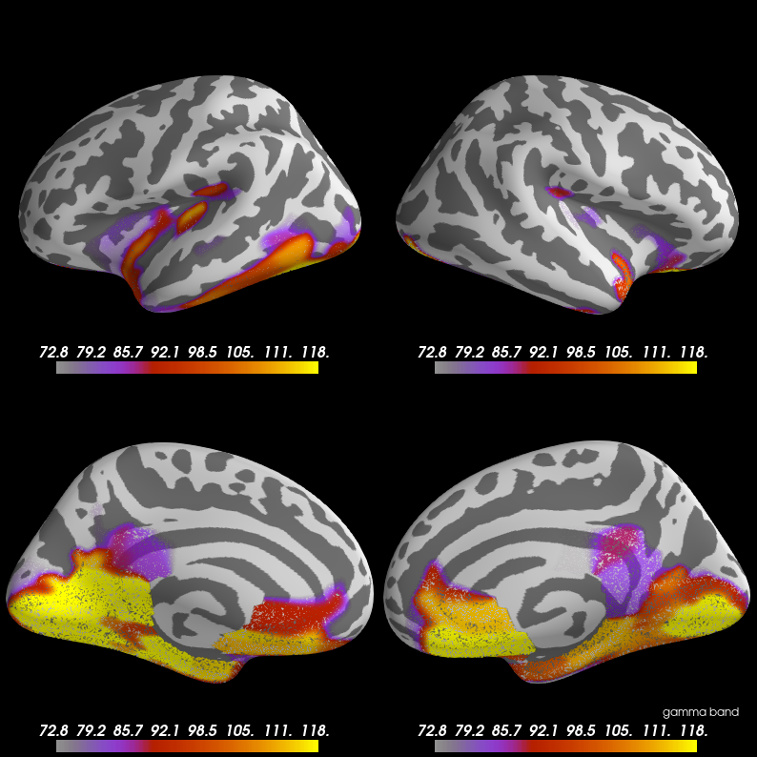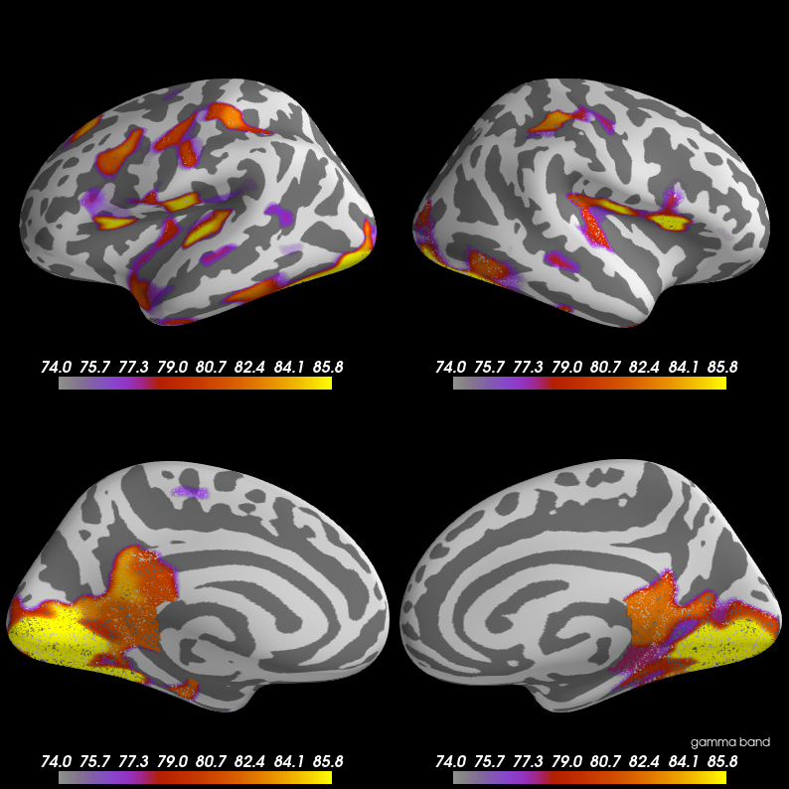

*Figure 2. Lateral and medial views of both hemispheres of the brain at 9 years of age (left) and 17 years of age (right) are shown. The degree of connectivity (yellow shows highest density) is mapped. Note the remarkable difference across the two ages in the distribution of degree connectivity, as well as the development of higher degree nodes in frontal and parietal cortices between 9 and 17 years.*